Operational Concept Description (OCD)

FlowerSeeker

Team 05

Name | Roles
Eder Figueroa | Primary Role: Project Manager/ Implementer.  Secondary Role: Tester.
Sophia Wu | Primary Role: Tester/ Trainer  Secondary Role: Implementer
Doris Lam | Primary Role: IIV&Ver/ Quality Focal Point/ Implementer.  Secondary Role: Tester.
Hiram Garcia | Primary Role: IIV&Ver/ Quality Focal Point/ Implementer.  Secondary Role: Tester.

4/1/2013

Version History
Date | Author | Version | Changes made | Rationale
10/03/12 | SW,YT | 1.0 | - Add section 1, section 2, and section 3.1 | - Initial draft for FlowerSeeker
10/10/12 | SW,YT | 1.1 | - Revise section 1.1, section 2, and section 3.1 | - Correct some mistakes in section 1.1, section 2, and section 3.1
10/14/12 | SW,YT | 2.0 | - Add section 3.2-3.4 | - Complete all section
10/22/12 | SW | 2.1 | - Fix minor bug | - Correction for document
10/23/12 | YT | 2.2 | - Fix minor bug | - Correction for document
10/30/12 | YT | 2.3 | - Fix minor bug in section 3 | - Correction for document
11/02/12 | YT,SW | 2.4 | - Fix minor bug | - Correction for document
11/04/12 | YT,SW | 2.5 | - Fix minor bug | - Correction for document
11/09/12 | SW | 2.6 | - Revise section 3.2.2 | - Correct the business workflow
12/10/12 | SW | 3.0 | - Revise section 1.2 | - Review and complete all sections
02/03/13 | SW | 3.1 | - Revise cover | - Reform development team
02/09/13 | SW | 3.2 | - Revise section 3.2.1 | - Reprioritize capability goals
04/01/13 | SW | 3.5 | - Revise section 2.3 | - Modify the boundary diagram

Table of Contents
Operational Concept Description (OCD) i
Version History ii
Table of Contents iii
Table of Tables iv
Table of Figures v
1. Introduction 1
1.1 Purpose of the OCD 1
1.2 Status of the OCD 1
2. Shared Vision 2
2.1 Benefits Chain 3
2.2 System Capability Description 3
2.3 System Boundary and Environment 4
3. System Transformation 5
3.1 Information on Current System 5
3.2 System Objectives, Constraints and Priorities 5
3.3 Proposed New Operational Concept 7
3.4 Organizational and Operational Implications 9

Table of Tables
Table 1: The Program Model 2
Table 2: Capability Goals Table 5
Table 3: Level of Service Goals Table 6

Table of Figures
Figure 1: Benefits Chain Diagram of FlowerSeeker 3
Figure 2: System Boundary and Environment Diagram of FlowerSeeker 4
Figure 3: Element Relationship Diagram of FlowerSeeker 7
Figure 4: Business Workflow Diagram of FlowerSeeker 8

Introduction

Purpose of the OCD
This document provides, in detail, the shared vision and goals of the stakeholders of the FlowerSeeker for Jessica Lee from USC Marshall School. The success-critical stakeholders of this project are Jessica Lee, as the project owner; Jessica’s mom, as florist contactor; Jessica’s sister and Jessica’s brother-in-law, as general marketing; prof. Mednick, as marketing consultant; florist and online shopper; as end user.

Status of the OCD
The status of OCD is currently at version 3.2, and is the final version of OCD, all sections are complete.

Shared Vision
Table 1: The Program Model
Assumptions:
- Florists want to have online presence.
- Customers want to build relationship with local florists.
- Customers want an easier way to buy flowers online and better shopping experience
- Customers don’t want flowers in box.
Stakeholders (Who?) | Initiatives (What?) | Value Propositions (Why?) | Beneficiaries (For Whom?)
- Developers  - Jessica Lee  - Florist  - Customers  - Jessica's mom  - Professor Mednick  - Jessica's sister and brother in law | - develop system  - marketing to get online shoppers  - create a tutorial for the florist to start up  - create some design that could license to the florist  - create a tutorial educate the consumers and tell them why choose flower seeker  - marketing at the florist level  - clarify legal issues | - increase control of the order arrangement, build relationship with the florist  - increase information status of the order  - increase choice of services  - increase information about their capability  - increase choice of florist  - increase choice of flower arrangement  - make the online purchase of flower is more pleasurable  - allow the florist to market their products to online shoppers  - easily/never done before  - increase cost saving for florist  - make better online prices of products | - Florists  - Customers

Benefits Chain
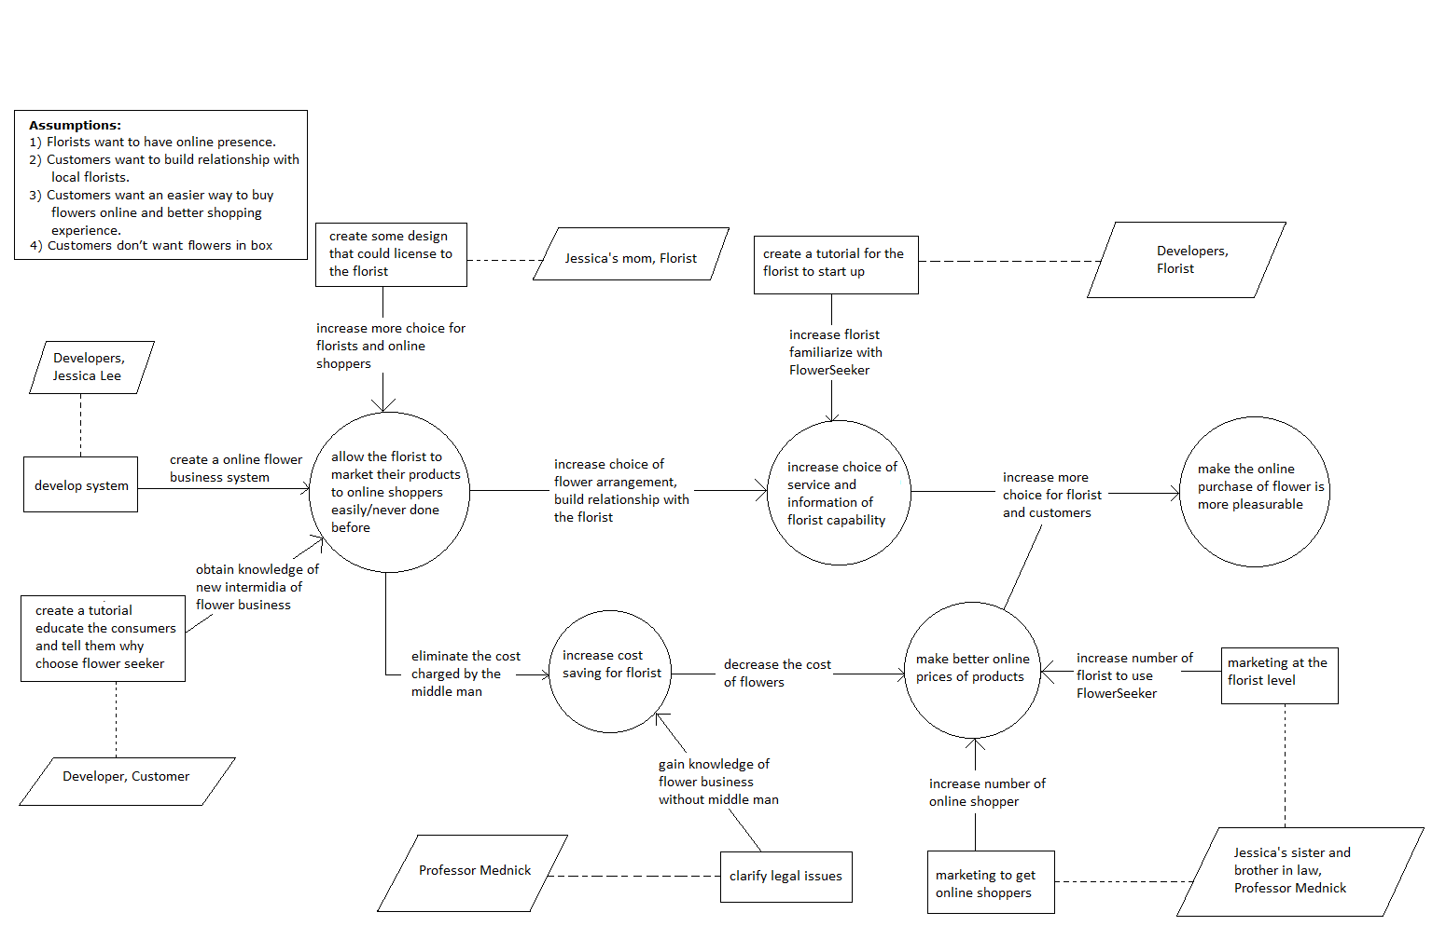
Figure 1: Benefits Chain Diagram of FlowerSeeker

System Capability Description
- The type of system to be built: eCommerce and social network.
- The target customer(s) for the system: florist and online shopper
- The need or opportunity that will be satisfied by the system: well arrangement for flowers and build directly connection between florists and online shopper.
- A compelling reason for the customer to buy/use the system: more choices of services for customers and better online price of products.
- The closest competitor of the system: Teleflora, FTD and 1-800-Flowers.
- The system's primary differentiation from, or benefit over, the closest competitor or alternative approach: Eliminate broker dealer in the florist industry, customize the online flower commerce and create a relationship for online shoppers and florists.

System Boundary and Environment
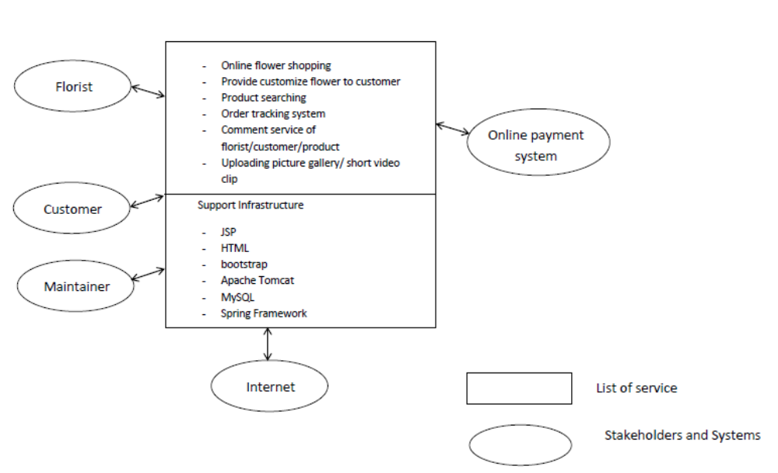
Figure 2: System Boundary and Environment Diagram of FlowerSeeker

System Transformation

Information on Current System

Infrastructure
It’s a new idea that needs to be realized and no such system/business exists as of now.

Artifacts
It’s a new idea that needs to be realized and no such system/business exists as of now.

Current Business Workflow
It’s a new idea that needs to be realized and no such system/business exists as of now.

System Objectives, Constraints and Priorities

Capability Goals
Table 2: Capability Goals Table
Capability Goals | Priority Level
OC-1 Search functionality: The system is capable of searching product by location, occasion, ranking, etc. | Must have
OC-2 Upload pictures: The system is capable of uploading pictures for product by florist. | Must have
OC-3 Subscription: The system is capable of making subscription and pay monthly fee by premium user. | Must have
OC-4 Ranking & Review: The system is capable of creating and updating rank and review to customer by florist and to product and florist by customer. | Must have
OC-5 Order Management: The system is capable of showing order history and status for florists to see how many customers purchased flowers from this florist. And also for online shoppers to check the order history to track previous orders they placed. | Must have
OC-6 Coupon Generation: The system is capable of generating coupons for florists to promote their products to specific customers. | Could have
OC-7 Upload Video: The system is capable of uploading videos for product by florist. | Could have
OC-8 Recommendation Engine: The system is capable to recommending customers | Could have

Level of Service Goals
Table 3: Level of Service Goals Table
Level of Service Goals | Priority Level | Referred WinWin Agreements
Response Time:  The system should show up pages within 8 seconds. | Must have | LOS-1
Interoperability:  The system website should show correctly in smart phone, mobile phone, and iPad. | Must have | LOS-2

Organizational Goals
OG-1: Making better online price of flower via building better relationship between online shoppers and florists by removing deal brokers.
OG-2: Increasing more choice of service via more choice of customize flower.
OG-3: Making better quality via better order tracking.
OG-4: Improving customer satisfaction via more efficiency local pickup service.

Constraints
Currently the client doesn’t specify any constraint to the project.

Relation to Current System
The relation to current system is how the florists will have to change how they receive orders and interact with customers

Proposed New Operational Concept

Element Relationship Diagram
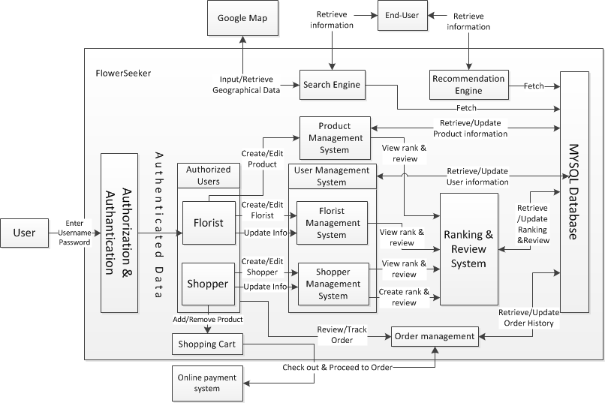
Figure 3: Element Relationship Diagram of FlowerSeeker

Business Workflows
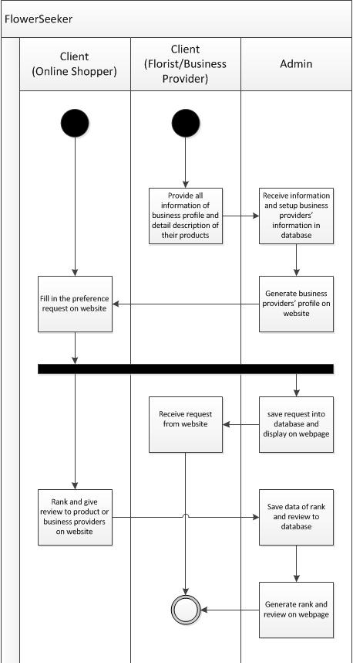
Figure 4: Business Workflow Diagram of FlowerSeeker

Organizational and Operational Implications

Organizational Transformations
- Due to this is a brand new system that the organization of the system was created just for this system; thus, there doesn’t have any changes to our system.

Operational Transformations
Since this is a new proposed system, we don’t have a current system yet. Below are operational transformations between our system and current online flower business.
- The option for new potential online shopper customizes flower arrangements online.
- The option for new potential florists to sell their goods online without deal brokers.
- Having order tracking system to make goods transportation more transparent.

